================================================================================
SECTION 1: ENVIRONMENT SETUP AND IMPORTS
================================================================================
✓ gdown already installed
✓ xgboost already installed
Installing scikit-learn...
✓ scikit-learn installed successfully
✓ shap already installed
✓ seaborn already installed
✓ pandas already installed
Installing tldextract...
✓ tldextract installed successfully

✓ All imports successful!

================================================================================
SECTION 2: GPU CONFIGURATION AND SYSTEM CHECK
================================================================================

--- GPU Status for XGBoost ---
✓ NVIDIA GPU detected
| 0 Tesla T4 Off | 00000000:00:04.0 Off | 0 |

--- System Resources ---
Total RAM: 12.67 GB
Available RAM: 11.08 GB
Free Disk Space: 74.11 GB

✓ Random seed set to 42 for reproducibility

================================================================================
SECTION 3: CONFIGURATION AND HYPERPARAMETERS
================================================================================

--- Configuration Summary ---
Training samples: 500,000
Test samples: 100,000
XGBoost estimators: 500
Max depth: 8
Learning rate: 0.1
Tree method: hist
Device: cuda

✓ Configuration loaded successfully!

================================================================================
SECTION 4: DATA DOWNLOAD AND EXTRACTION
================================================================================

Step 1: Mounting Google Drive...
Mounted at /content/drive
✓ Google Drive mounted successfully!

Step 2: Downloading dataset...

--- Downloading Dataset ---
File ID: 16iWDam4flWoyrga-42VlNogohx6nPXYm
Downloading... (this may take a few minutes)
Downloading...
From (original): https://drive.google.com/uc?id=16iWDam4flWoyrga-42VlNogohx6nPXYm
From (redirected): https://drive.google.com/uc?id=16iWDam4flWoyrga-42VlNogohx6nPXYm&confirm=t&uuid=3feb7767-77b5-430b-ae0d-8ff6bdbd68c5
To: /content/dataset.zip
100%|██████████| 143M/143M [00:03<00:00, 41.8MB/s]
✓ Download complete! File size: 136.62 MB

Step 3: Extracting dataset...

--- Extracting Dataset ---
Extracting /content/dataset.zip...
✓ Extraction complete!

================================================================================
SECTION 5: FEATURE ENGINEERING
================================================================================

--- Testing Feature Extraction ---
Test URL: http://secure-login.paypal.com.suspicious-site.xyz/verify?id=12345
Number of features: 47

Sample features:
url_length: 66
domain_length: 15
path_length: 7
query_length: 8
fragment_length: 0
num_dots: 4
num_hyphens: 2
num_underscores: 0
num_slashes: 3
num_question_marks: 1

✓ Feature extractor ready with 47 features!

================================================================================
SECTION 6: DATA LOADING AND PREPROCESSING
================================================================================

⏳ Loading and preprocessing data (this may take several minutes)...

--- Loading Training Data ---
Loading: benign_Train.txt...
Total URLs in file: 2,000,000
Sampled: 250,000 URLs
Loading: malign_Train.txt...
Total URLs in file: 2,000,000
Sampled: 250,000 URLs

Total training URLs: 500,000

--- Loading Test Data ---
Loading: benign_Test.txt...
Total URLs in file: 1,087,717
Sampled: 50,000 URLs
Loading: malign_Test.txt...
Total URLs in file: 1,480,467
Sampled: 50,000 URLs

Total test URLs: 100,000

--- Extracting Features (Training Data) ---
Processed 50,000/500,000 URLs (10.0%)
Processed 100,000/500,000 URLs (20.0%)
Processed 150,000/500,000 URLs (30.0%)
Processed 200,000/500,000 URLs (40.0%)
Processed 250,000/500,000 URLs (50.0%)
Processed 300,000/500,000 URLs (60.0%)
Processed 350,000/500,000 URLs (70.0%)
Processed 400,000/500,000 URLs (80.0%)
Processed 450,000/500,000 URLs (90.0%)
Processed 500,000/500,000 URLs (100.0%)

--- Extracting Features (Test Data) ---
Processed 50,000/100,000 URLs (50.0%)
Processed 100,000/100,000 URLs (100.0%)

--- Cleaning Data ---

--- Creating Validation Split ---
Training set: 450,000 samples
Validation set: 50,000 samples
Test set: 100,000 samples
Number of features: 47

--- Data Summary ---
X_train shape: (450000, 47)
X_val shape: (50000, 47)
X_test shape: (100000, 47)
Feature names: ['url_length', 'domain_length', 'path_length', 'query_length', 'fragment_length', 'num_dots', 'num_hyphens', 'num_underscores', 'num_slashes', 'num_question_marks']...

✓ Data loading and preprocessing complete!

================================================================================
SECTION 7: DATA VISUALIZATION
================================================================================
Results will be saved to: /content/results_xgboost

--- Generating Data Visualizations ---
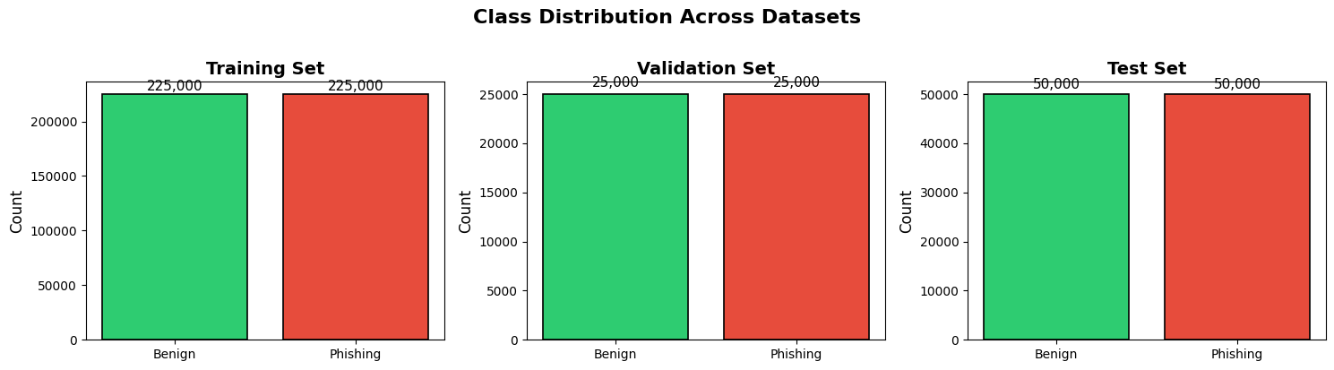
✓ Class distribution plot saved!
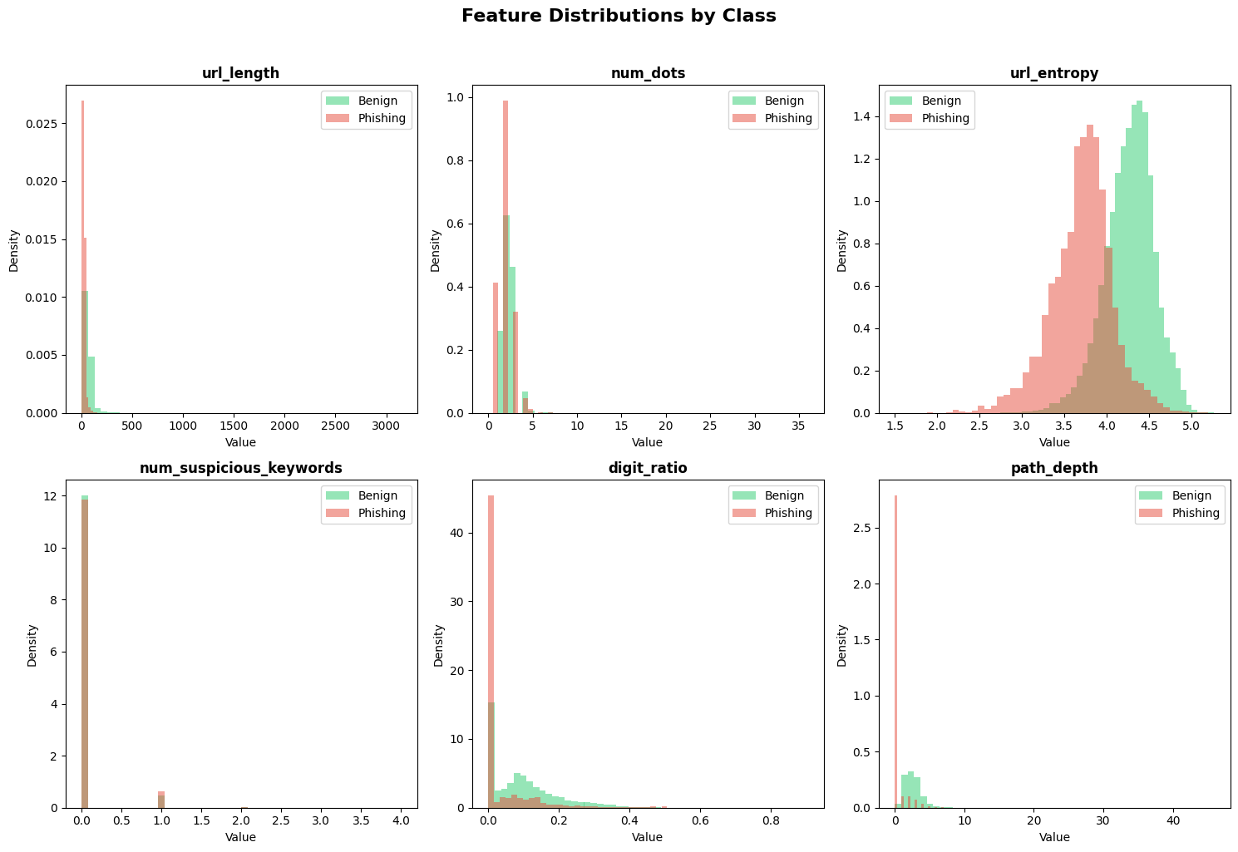
✓ Feature distributions plot saved!
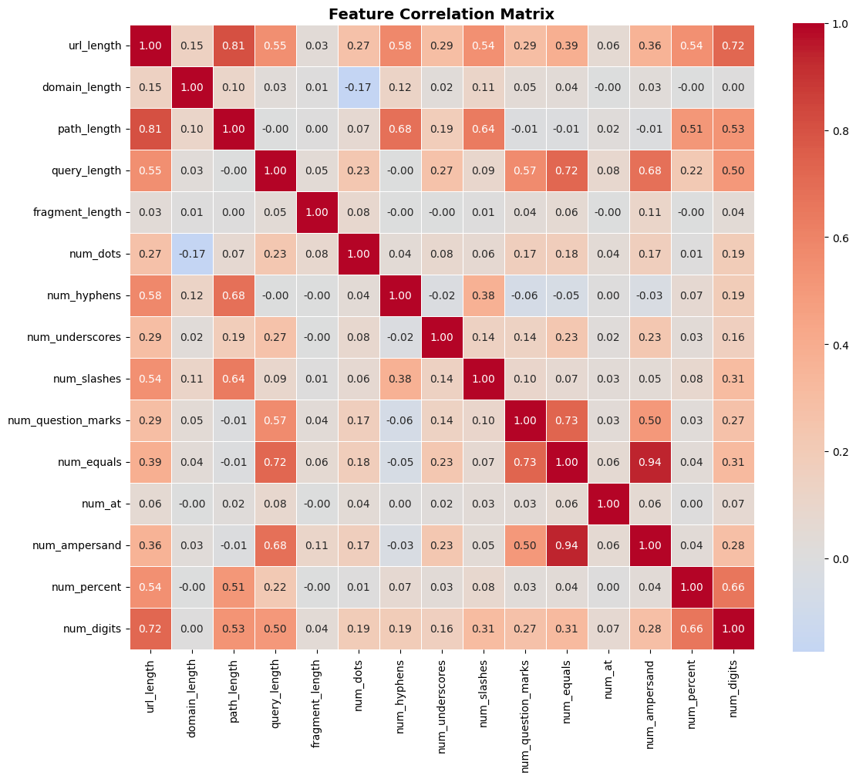
✓ Correlation matrix saved!

================================================================================
SECTION 8: FEATURE SCALING
================================================================================

--- Feature Scaling (Optional for XGBoost) ---
XGBoost is tree-based and doesn't require scaling.
Keeping original features for better interpretability.

✓ 47 features ready for training

================================================================================
SECTION 9: MODEL TRAINING
================================================================================

⏳ Starting XGBoost training...

--- Training XGBoost Model ---
Training samples: 450,000
Validation samples: 50,000
Number of features: 47
Tree method: hist
Device: cuda

Hyperparameters:
n_estimators: 500
max_depth: 8
learning_rate: 0.1
subsample: 0.8
colsample_bytree: 0.8
min_child_weight: 5
gamma: 0.1
reg_alpha: 0.1
reg_lambda: 1.0
scale_pos_weight: 1
random_state: 42
n_jobs: -1
tree_method: hist
device: cuda

--------------------------------------------------
Training started at: 2026-01-11 17:49:52
--------------------------------------------------
[0] validation_0-logloss:0.61300 validation_1-logloss:0.61307
[50] validation_0-logloss:0.10696 validation_1-logloss:0.11017
[100] validation_0-logloss:0.09589 validation_1-logloss:0.10153
[150] validation_0-logloss:0.08939 validation_1-logloss:0.09824
[200] validation_0-logloss:0.08423 validation_1-logloss:0.09612
[250] validation_0-logloss:0.08046 validation_1-logloss:0.09512
[300] validation_0-logloss:0.07676 validation_1-logloss:0.09441
[350] validation_0-logloss:0.07358 validation_1-logloss:0.09394
[400] validation_0-logloss:0.07088 validation_1-logloss:0.09368
[450] validation_0-logloss:0.06824 validation_1-logloss:0.09354
[499] validation_0-logloss:0.06604 validation_1-logloss:0.09330

--------------------------------------------------
Training completed at: 2026-01-11 17:49:58
Total training time: 0.11 minutes
Best iteration: 499
--------------------------------------------------

================================================================================
SECTION 10: TRAINING VISUALIZATION
================================================================================

--- Plotting Training History ---
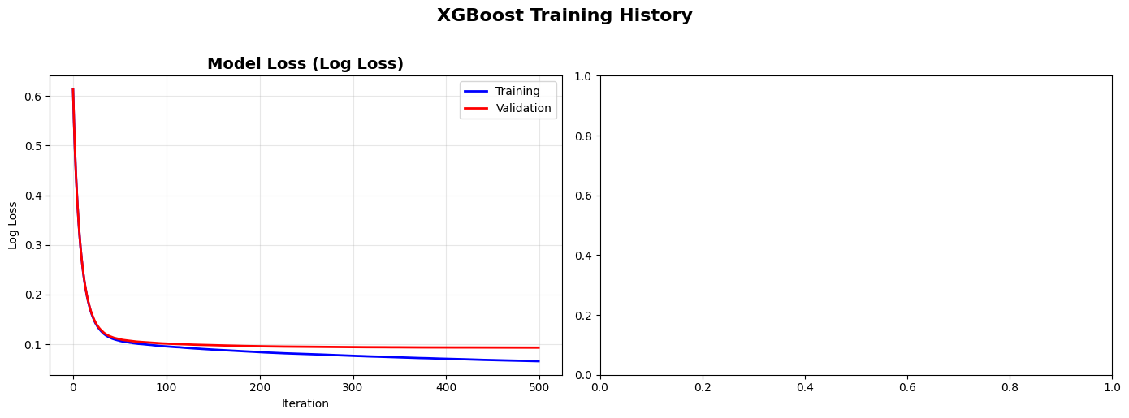
✓ Training history plot saved!

================================================================================
SECTION 11: MODEL EVALUATION
================================================================================

--- Evaluating Model on Test Set ---
Test samples: 100,000
Generating predictions...

========================================
METRIC VALUE
========================================
Accuracy 0.9636
Precision 0.9789
Recall 0.9477
F1-Score 0.9630
ROC-AUC 0.9942
========================================

--- Detailed Classification Report ---
precision recall f1-score support

Benign 0.95 0.98 0.96 50000
Phishing 0.98 0.95 0.96 50000

accuracy 0.96 100000
macro avg 0.96 0.96 0.96 100000
weighted avg 0.96 0.96 0.96 100000

--- Plotting Confusion Matrix ---
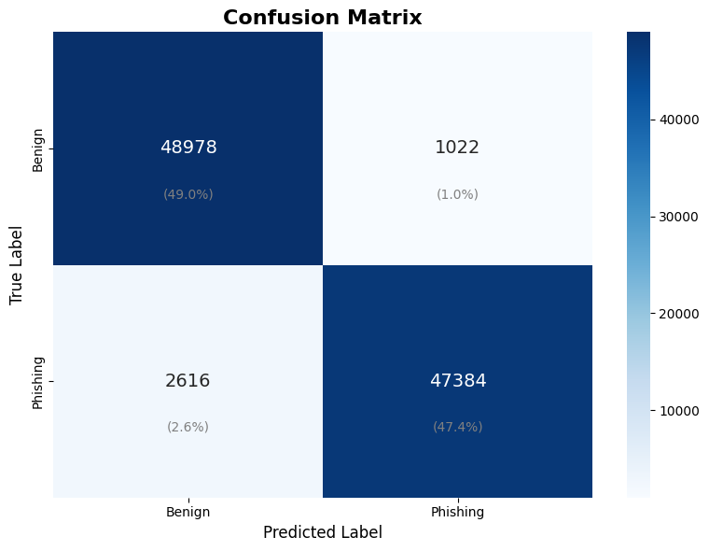

Confusion Matrix Details:
True Negatives: 48,978
False Positives: 1,022
False Negatives: 2,616
True Positives: 47,384

✓ Confusion matrix saved!

--- Plotting ROC Curve ---
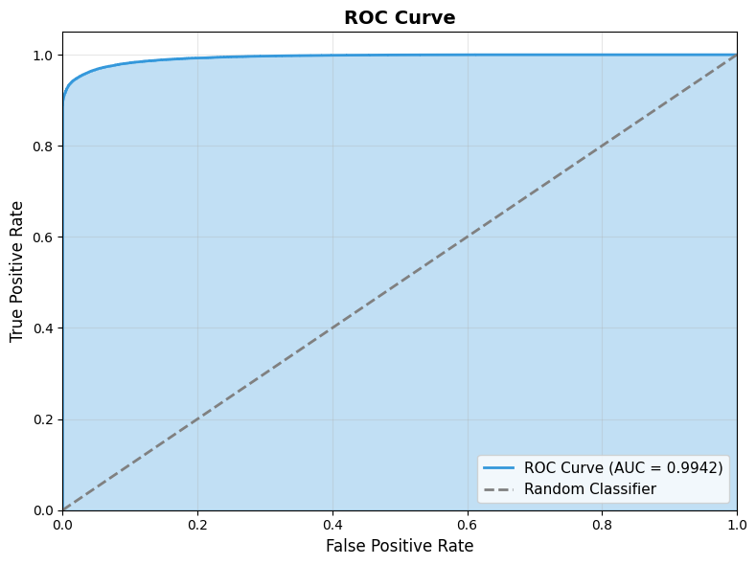

Optimal threshold: 0.5488

✓ ROC curve saved!

--- Plotting Precision-Recall Curve ---
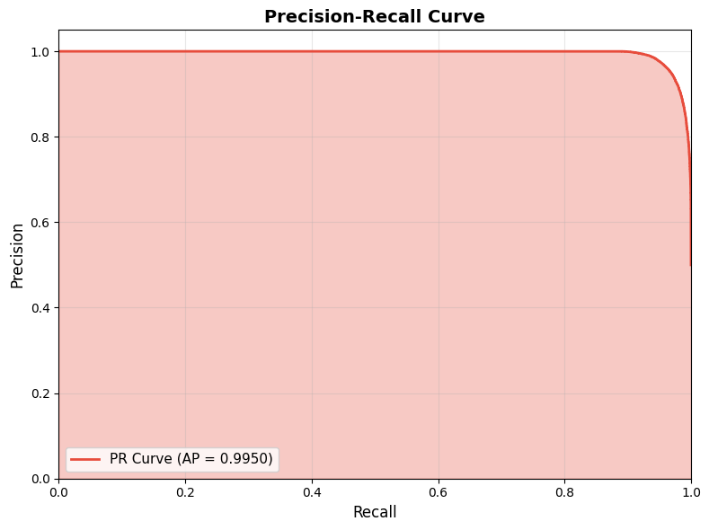

✓ Precision-Recall curve saved!

================================================================================
SECTION 12: FEATURE IMPORTANCE ANALYSIS
================================================================================

--- Feature Importance Analysis ---
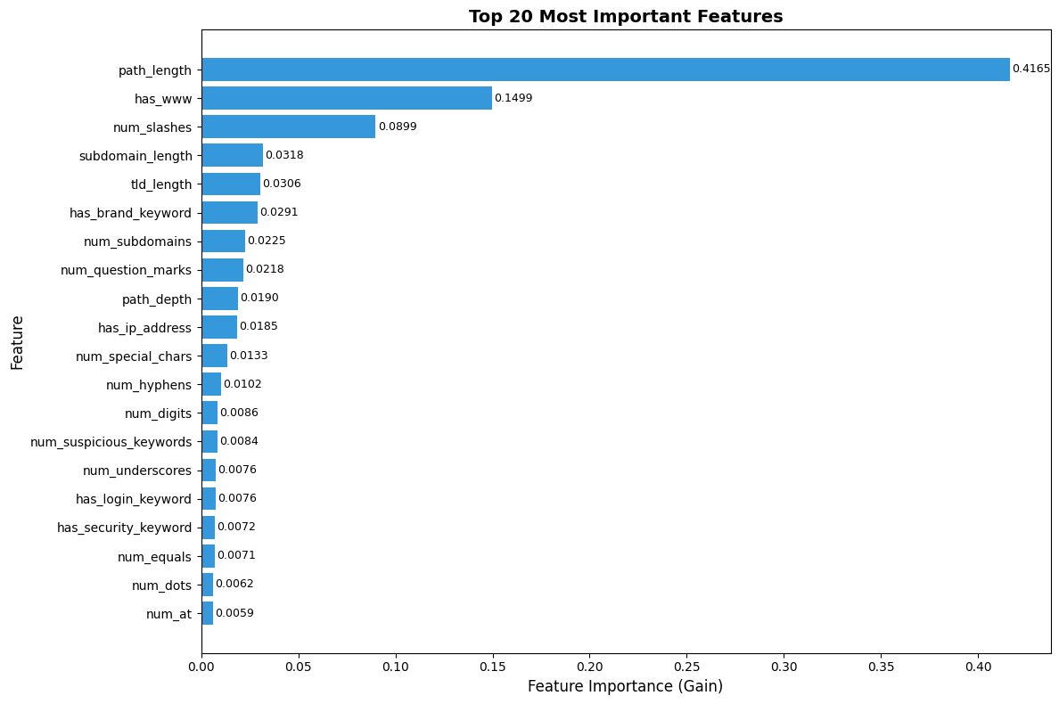

Top 20 Most Important Features:
1. path_length: 0.4165
2. has_www: 0.1499
3. num_slashes: 0.0899
4. subdomain_length: 0.0318
5. tld_length: 0.0306
6. has_brand_keyword: 0.0291
7. num_subdomains: 0.0225
8. num_question_marks: 0.0218
9. path_depth: 0.0190
10. has_ip_address: 0.0185
11. num_special_chars: 0.0133
12. num_hyphens: 0.0102
13. num_digits: 0.0086
14. num_suspicious_keywords: 0.0084
15. num_underscores: 0.0076
16. has_login_keyword: 0.0076
17. has_security_keyword: 0.0072
18. num_equals: 0.0071
19. num_dots: 0.0062
20. num_at: 0.0059

✓ Feature importance plot saved!

================================================================================
SECTION 13: MODEL EXPLAINABILITY (SHAP)
================================================================================

--- SHAP Explainability Analysis ---
Using 1000 samples for SHAP analysis
Creating SHAP explainer...
Calculating SHAP values...

--- SHAP Summary Plot ---
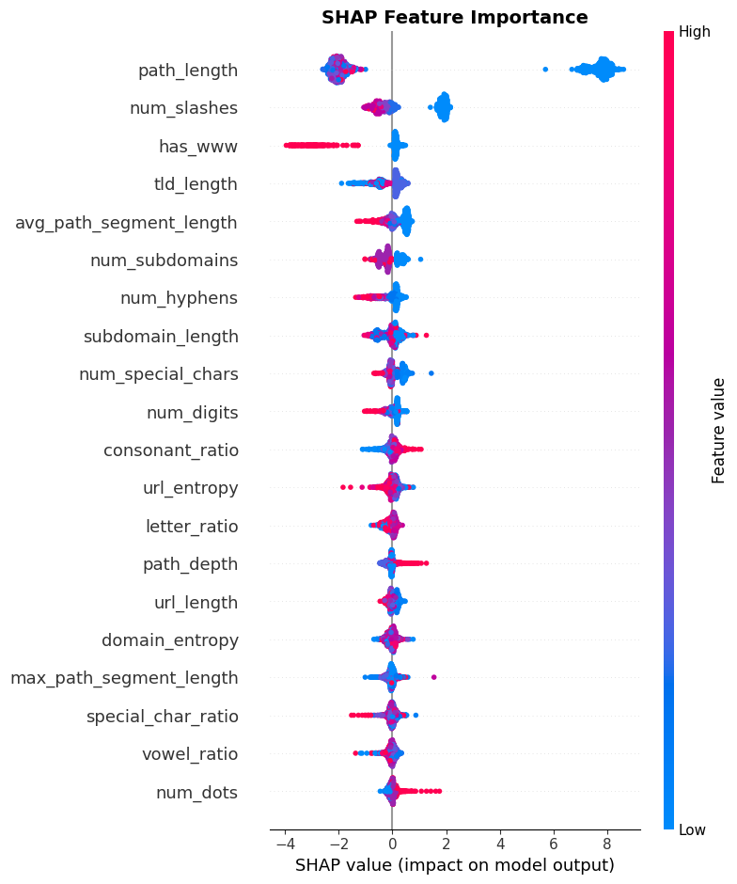

--- SHAP Bar Plot ---
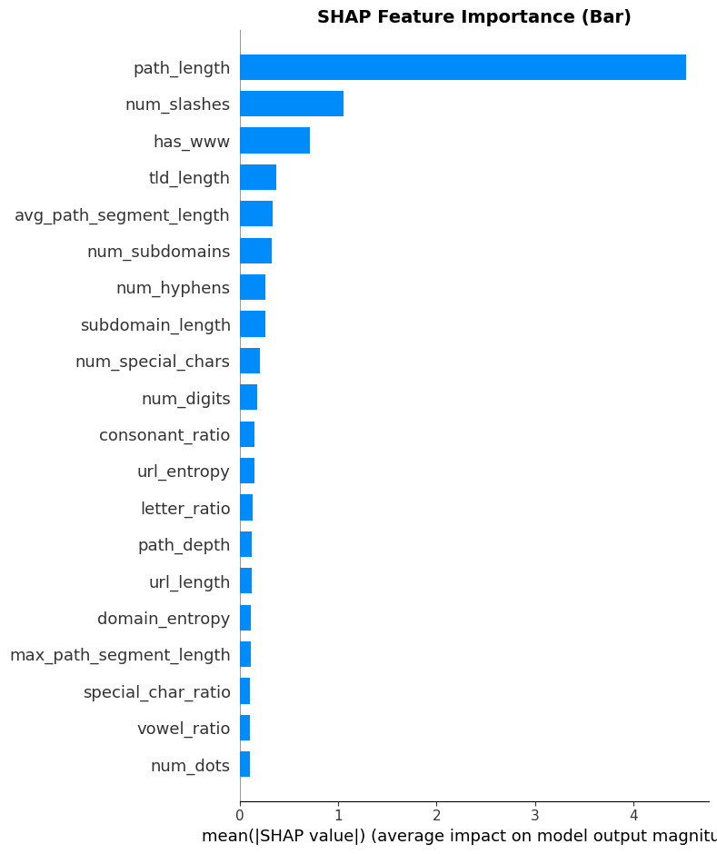

✓ SHAP analysis complete!

================================================================================
SECTION 14: MODEL SAVING AND LOADING
================================================================================

--- Saving Model ---
✓ Model saved to: /content/phishing_detector_xgboost.json
Model size: 4.95 MB
✓ Feature names saved to: /content/phishing_detector_xgboost_features.pkl

--- Loading and Verifying Model ---
✓ Model loaded from: /content/phishing_detector_xgboost.json
✓ Verification accuracy on 1000 samples: 0.9760

✓ Model loading and verification successful!

================================================================================
SECTION 15: PREDICTION FUNCTION FOR NEW URLs
================================================================================

--- Testing Prediction Function ---

Predictions for sample URLs:

============================================================
URL: google.com
============================================================
⚠️ PREDICTION: PHISHING
🔴 Phishing Probability: 100.00%
Confidence: 100.00%
============================================================

============================================================
URL: facebook.com/login
============================================================
⚠️ PREDICTION: PHISHING
🔴 Phishing Probability: 97.69%
Confidence: 97.69%
============================================================

============================================================
URL: secure-banking-login.suspicious-site.com/verify
============================================================
✅ PREDICTION: BENIGN
🟢 Benign Probability: 85.22%
Confidence: 85.22%
============================================================

============================================================
URL: paypal.com.fake-domain.net/signin
============================================================
⚠️ PREDICTION: PHISHING
🔴 Phishing Probability: 55.38%
Confidence: 55.38%
============================================================

============================================================
URL: amazon.com
============================================================
⚠️ PREDICTION: PHISHING
🔴 Phishing Probability: 100.00%
Confidence: 100.00%
============================================================

============================================================
URL: free-iphone-winner.xyz/claim-prize
============================================================
✅ PREDICTION: BENIGN
🟢 Benign Probability: 73.39%
Confidence: 73.39%
============================================================

============================================================
URL: github.com/user/repo
============================================================
✅ PREDICTION: BENIGN
🟢 Benign Probability: 61.16%
Confidence: 61.16%
============================================================

============================================================
URL: login-verify-account.com/secure/bank
============================================================
⚠️ PREDICTION: PHISHING
🔴 Phishing Probability: 73.96%
Confidence: 73.96%
============================================================

================================================================================
SECTION 16: FINAL SUMMARY AND RESULTS EXPORT
================================================================================

================================================================================
FINAL TRAINING REPORT
================================================================================

╔══════════════════════════════════════════════════════════════════════════════╗
║ PHISHING URL DETECTION MODEL ║
║ XGBoost Classifier ║
╠══════════════════════════════════════════════════════════════════════════════╣
║ DATASET INFORMATION ║
╠══════════════════════════════════════════════════════════════════════════════╣
║ Training Samples: 500,000 ║
║ Validation Split: 10% ║
║ Test Samples: 100,000 ║
║ Number of Features: 47 ║
╠══════════════════════════════════════════════════════════════════════════════╣
║ MODEL CONFIGURATION ║
╠══════════════════════════════════════════════════════════════════════════════╣
║ Algorithm: XGBoost ║
║ N Estimators: 500 ║
║ Max Depth: 8 ║
║ Learning Rate: 0.1 ║
║ Tree Method: hist ║
║ Device: cuda ║
╠══════════════════════════════════════════════════════════════════════════════╣
║ TRAINING INFORMATION ║
╠══════════════════════════════════════════════════════════════════════════════╣
║ Training Time: 0.11 min ║
║ Best Iteration: 499 ║
╠══════════════════════════════════════════════════════════════════════════════╣
║ EVALUATION METRICS (TEST SET) ║
╠══════════════════════════════════════════════════════════════════════════════╣
║ Accuracy: 0.9636 ║
║ Precision: 0.9789 ║
║ Recall: 0.9477 ║
║ F1-Score: 0.9630 ║
║ ROC-AUC: 0.9942 ║
╚══════════════════════════════════════════════════════════════════════════════╝

--- Top 10 Most Important Features ---
1. path_length 0.4165
2. has_www 0.1499
3. num_slashes 0.0899
4. subdomain_length 0.0318
5. tld_length 0.0306
6. has_brand_keyword 0.0291
7. num_subdomains 0.0225
8. num_question_marks 0.0218
9. path_depth 0.0190
10. has_ip_address 0.0185

✓ Results summary saved to: /content/results_xgboost/results_summary.json

--- Saved Files ---
✓ Trained Model: /content/phishing_detector_xgboost.json (5065.5 KB)
✓ Feature Names: /content/phishing_detector_xgboost_features.pkl (0.8 KB)
✓ Results Summary: /content/results_xgboost/results_summary.json (2.3 KB)
✓ Training History Plot: /content/results_xgboost/training_history.png (59.5 KB)
✓ Confusion Matrix: /content/results_xgboost/confusion_matrix.png (51.0 KB)
✓ ROC Curve: /content/results_xgboost/roc_curve.png (62.6 KB)
✓ PR Curve: /content/results_xgboost/precision_recall_curve.png (37.1 KB)
✓ Feature Importance: /content/results_xgboost/feature_importance.png (123.1 KB)
✓ SHAP Summary: /content/results_xgboost/shap_summary.png (179.8 KB)
✓ Class Distribution: /content/results_xgboost/class_distribution.png (58.2 KB)

================================================================================
SECTION 17: DOWNLOAD FILES
================================================================================

--- Creating Download Package ---
✓ Download package created: /content/phishing_detection_xgboost_results.zip (2.38 MB)

📥 Click below to download the results:

================================================================================
TRAINING COMPLETE!
================================================================================

🎉 Congratulations! Your XGBoost phishing URL detection model is ready!

📊 Model Performance:
• Accuracy: 96.36%
• Precision: 97.89%
• Recall: 94.77%
• F1-Score: 96.30%
• ROC-AUC: 0.9942

📁 Files Saved:
• Model: /content/phishing_detector_xgboost.json
• Results: /content/results_xgboost/
• Download: /content/phishing_detection_xgboost_results.zip

🔮 To use the model for predictions:
detector = PhishingURLDetector(model, feature_extractor)
result = detector.predict("suspicious-url.com")

📝 For your FYP report, all visualizations are saved in the results folder.

🚀 XGBoost Advantages:
• Fast training and inference
• Interpretable feature importance
• No GPU required (but benefits from it)
• Excellent for tabular/structured data

Good luck with your Final Year Project! 🎓

================================================================================

